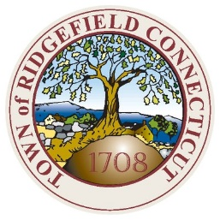
TOWN OF RIDGEFIELD
VILLAGE DISTRICT CONSULTANTS
ARCHITECTURAL ADVISORY COMMITTEE

Policy: Village District Consultants and Architectural Advisory Committee meetings will be conducted under Roberts Rules of Order and all participants are expected to conduct themselves with dignity and treat all those present with respect, empathy and civility.

February 14, 2023 MEETING AGENDA
(Meeting begins at 7:30p.m)

VILLAGE DISTRICT CONSULTANT Meeting Room (lower level)
Tuesday, February 14, 2023 Town Hall Annex
7:30 p.m. 66 Prospect Street

Item I: (Contd.) 451 Main Street, VDC-22-12
“CVS”
Free standing sign

Ms. Andrews will attend.
Plans, details, and all documents on file for the above items may be viewed at the following link:
https://ridgefieldct.viewpointcloud.com/records/90060

ARCHITECTURAL ADVISORY COMMITTEE Meeting Room (lower level)

Tuesday, February 14, 2022 Town Hall Annex
Immediately following VDC agenda items 66 Prospect Street

Item I: 10 Kingswood Lane AAC-23-1
Pool in the front yard (the house has two frontages)

Ms.DeMeci will attend.

Plans, details, and all documents on file for the above items may be viewed at the following link:
https://ridgefieldct.viewpointcloud.com/records/90344

Item II: 100 Danbury Road Unit CMN AAC-23-2
“adding utility sheds to already approved townhomes”

Mr. Mose will attend.

Plans, details, and all documents on file for the above items may be viewed at the following link:
https://ridgefieldct.viewpointcloud.com/records/90682

